
UNIVERSITAS SRIWIJAYA
FAKULTAS ILMU KOMPUTER
JURUSAN TEKNIK INFORMATIKA
Jalan Palembang – Prabumulih Km. 32 Inderalaya Ogan Ilir Kode Pos 30662
Telepon (0711) 7072729, 379249, 581700 Fax (0711) 379248, 581710

SOAL UJIAN TENGAH SEMETER GANJIL 2019-2020

Mata Kuliah : SQA Dosen : Danny Saputra, M.Sc.
Jurusan : Teknik Informatika
Waktu : 60 menit
Kelas : Sifat : Buku Tertutup (Close book)
Hari / Tanggal : Ket. : Teori, soal, nilai max 100

Petunjuk: 1. Jawablah pertanyaan termudah dahulu,
2. Tulislah jawaban dengan jelas, bersih dan terbaca,
3. Nilai tertera pada setiap akhir soal.

1.Name 1 advantages and 1 disadvantage of using prototyping model [10]
2.Explain verification, validation and qualification base on IEEE Std 610.12-1990 (IEEE, 1990) [10]
3. Peer review and Design review some times consist of the same people what are 2 main difference between the two reviews?[10]
4. What is software testing [10]
5.Name one direct objective and one indirect objective of software testing[10]
6.What are stub and drivers and when are they used?[10]
7. define black box testing and white box testing base on IEEE difinitions [5]
8. How many independent path base on the diagram below [5]
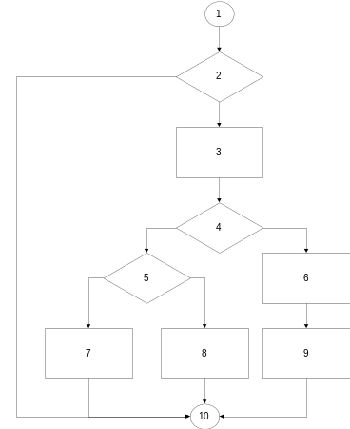
9.When creating a plan for planning what are 5 things that should be considered [10]
10. Name one advantages and disadvantages of automated testing [5]
11. What is the main difference between apha and beta testing based on loacation [5]
12. Name 3 types of maintenance services [10]

SELAMAT BEKERJA SEMOGA BERHASIL

